Setting up Application Environment

Install IBM Cloud CLI

Step 1. Navigate to cloud.ibm.com

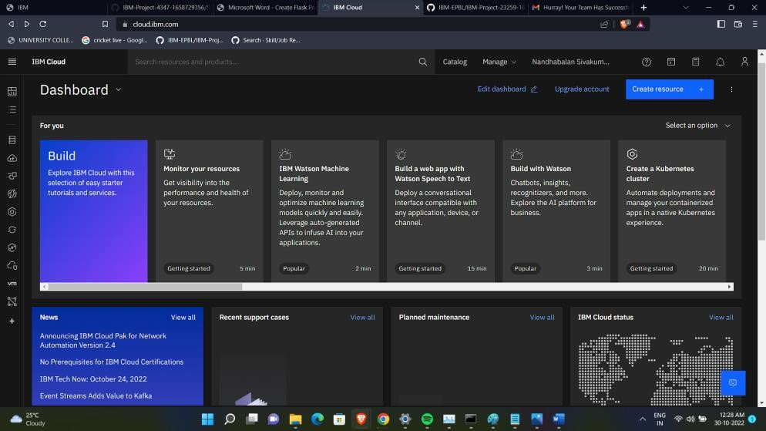

Step 2. Search on Container Registry and give get started and follow the steps to install IBM Cloud CLI

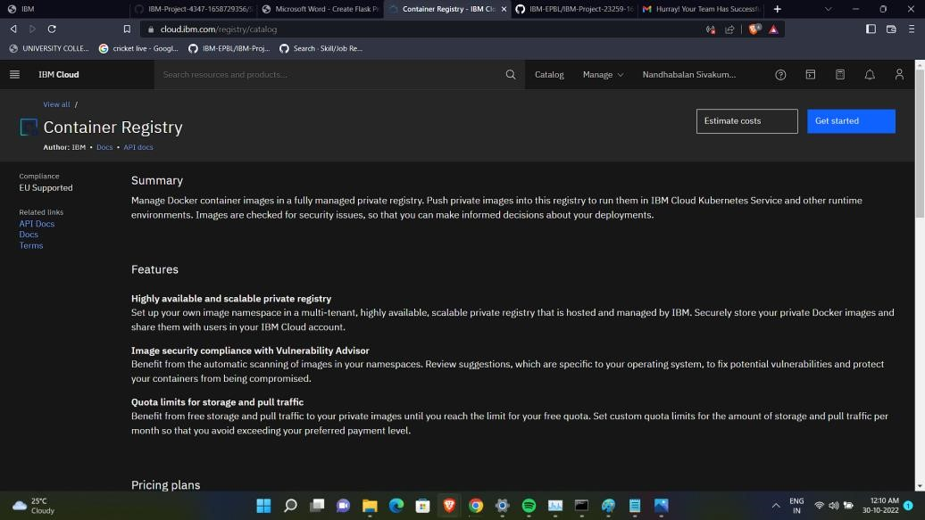

Step

3

. Download

windows

64

-

bit

installer

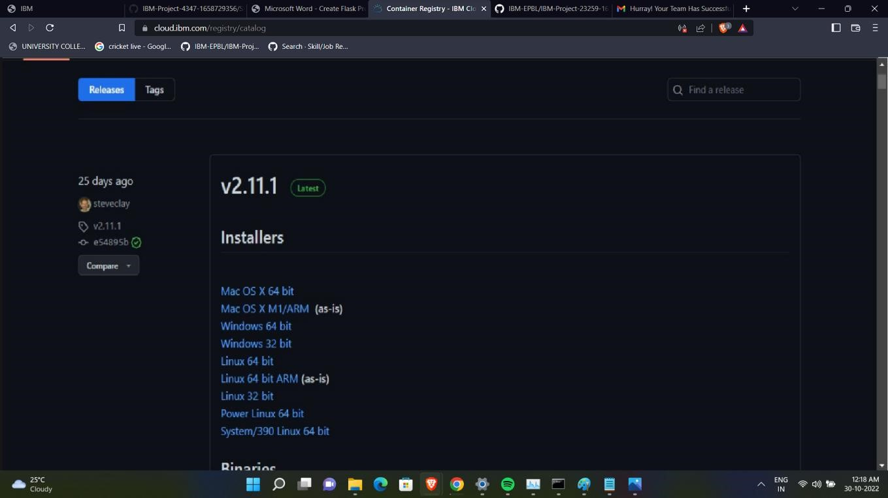

Step 4. Open the downloaded .exe file and run it to install IBM Cloud CLI

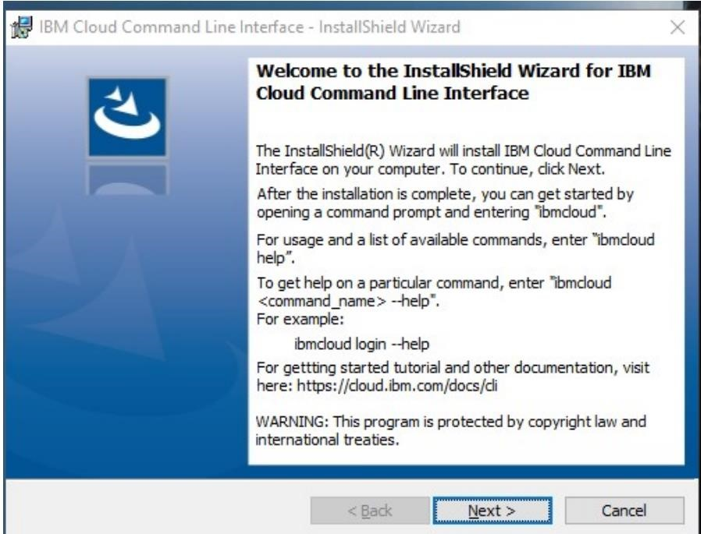

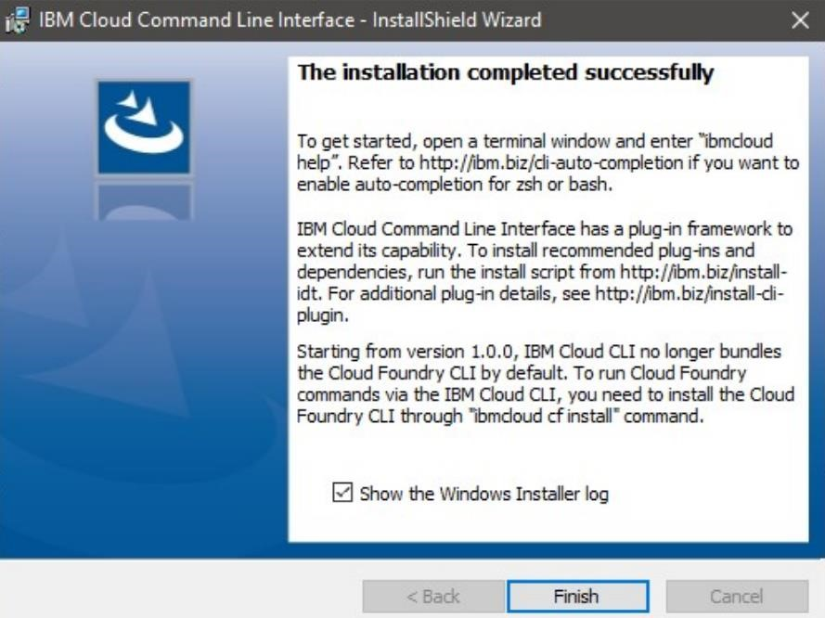

|  |  |
| --- | --- |
| SKILL AND JOB RECOMMENDER APPLICATION    OUTPUT:  IBM Cloud CLI is installed successfully | PNT2022TMID39291 |